**Foundation Program**

Exam **Revision** 201603

Unit Code: **FNDB020**

Unit Name: **Accounting**

Reading Time: **15 minutes**

Writing Time: **2 hours**

**READ INSTRUCTIONS BEFORE COMMENCING**

**Do not commence writing until instructed to do so**

**Note:** A tick, (√), in a box indicates the instruction applies. A blank box indicates the instruction does not apply.

🗸

This exam is a **closed book** exam

This exam is an **NOT** **open book** exam.

🗸

You may use a (non-electronic) **dictionary**

🗸

You may use a **calculator**

.

Part - A Multiple Choice

**10 questions – 1 mark each question – total 10 marks**

Part – B Short Answer

**5 questions – 4 marks each – total 20 marks**

**Part C - Extended Answer**

**Questions – 10 marks each – total 20 marks**

**Part - A Multiple Choice**

1. The principle stating that all expenses incurred while earning revenues should be identified with the revenues when they are earned, and reported for the same time period is the:

A) cost principle.

B) revenue principle.

D) matching principle.

E) timing principle.

1. A business has a number of debts due within two months. They are waiting on payments from customers which will take three months to collect. The business is facing:

A) Credit risk

B) Insolvency risk

C) Liquidity risk

D) Operational risk

1. What is depreciation?

A) Cost of a fixed asset

B) Cost of a fixed asset’s repair

C) The residual value of a fixed asset

D) Portion of a non current asset’s cost consumed during the current accounting period

1. A vehicle was purchased on December 1st, 2014. The vehicle cost $54000 and was expected to be kept for 4 years before being sold for $6000. How much depreciation will be allocated for the year ending 31st December 2014 using the straight line method?
2. $13500
3. $12000
4. $4000
5. $1000
6. What is the final total in the Total Paid (Bank) column of this cash payments journal?

|  |  |  |  |  |  |  |  |
| --- | --- | --- | --- | --- | --- | --- | --- |
| **Date** | **Details** | **Chq. No.** | **Total paid (Bank)** | **Rent paid** | **Drawings** | **GST Paid** | **Sundry payments** |
| April 1st | TOTAL | 2851xy | **?** | $3,200 | $1,200 | $875 | $1,125 |

The Total Paid (Bank) column should be equal to:

1. $5,500
2. $6,400
3. $6,485
4. Not enough information provided to calculate the Total Paid (Bank) column
5. When completing a budget variance report, a favorable variance is:
   1. A situation where revenue and expenses are less than what was budgeted
   2. The difference between the bank balance at the start of the period and the estimated balance at the end of the period
   3. A situation where the actual result is better than the result predicted in the budget
   4. A situation where the actual result is worse than the result predicted in the budget
6. What effect will the following transaction have on the accounting equation of this business?

*The business sold stock for $2,000, plus GST $200, cost price is $800*

1. Assets 🡹 1,400 Liabilities 🡹 $200 Owner’s Equity 🡹$1,200
2. Assets 🡹$2,200 Liabilities 🡹$200 Owner’s Equity 🡹$2,000
3. Assets ⬇$1,400 Liabilities ⬇$200 Owner’s Equity ⬇$1,200
4. Assets ⬇$2,200 Liabilities ⬇$200 Owner’s Equity ⬇$2,000
5. The major difference between service firms and retail firms is:
6. Service firms sell for cash only, whereas retail businesses make both cash and credit sales
7. Retail firms need to account for GST, service firms do not
8. Retail firms buy and sell goods in order to make a profit, whereas service firms do not
9. Service firms are more profitable than trading firms
10. Which of the following transactions would feature in both the Statement of Receipts and Payments and the Income Statement?
11. Stock purchased on credit
12. Rent paid
13. Sales made on credit
14. Engaged the services of a painter
15. The qualitative characteristic that emphasizes the need to be able to check accounting information against business documents is known as:
16. Comparability
17. Reliability
18. Understandability
19. Relevance

**Part B Short Answer**

3. Sports Gear Pty Ltd has developed the following information for the sports bag it sells.

Sales price is $90 per bag, variable cost is $63 per bag and total fixed costs are $1,350,000

**Required:**

**SOLUTION**

1. How many sports bags must they sell to break even? Show in both number of units and in total sales dollars.

Contribution margin is 90-63 = 27

Fixed costs are 1,350,000 divided by margin 27 = 50,000 units

$90 per bag and 50,000 bags = total sales dollars of $4,500,000

1. How many sports bags must they sell in order to generate a profit of $60,000?

Show in both number of units and in total sales dollars.

Fixed costs 1,350,000 + desired profit $60,000 = $1,410,000

1,410,000 divided by margin 27 = 52,223 units

= $4,700,070

1. In the year ending 31/12/2011 they sold 62,000 sports bags. Showing your calculations, what is the profit for the year?.

62,000 x margin 27 = $1,674,000

$1,674,000 less fixed costs $1,350,000 = $324,000

1. If the variable expenses per unit decreased by $6.00. And the Sales price increased to $97 how many bags would need to be sold to break even

New sales price $97 less new variable cost (63-6) $57 = contribution margin of $40

Fixed costs $1,350,000 divided by margin $40 = 33,750 units

**Business Transaction**

1. Prepaid rent expired during the year, $6,000.

1. Depreciation on Sports Equipment was $3,000 for the year
2. Electricity expenses of $550 were unpaid at year end (i.e. balance date)

1. Supplies purchased during the year totalled $800. At year end, only $150 of supplies remained on hand
2. Interest of $320 had been earned on an investment, but cash has not been received.

1. Unpaid Wages at year end amounted to $5,000.
2. Cash of $8,000 had been received in advance for Basketball Camps to be held in the future. This was recorded as Unearned Revenue. By year end all the revenue had been earned.

**Required:**

Prepare the necessary adjusting entries in the general journal entries on balance date 30 June 2017.

|  |  |  |  |
| --- | --- | --- | --- |
| **Date** | **Details** | **Debit** | **Credit** |
|  |  |  |  |
|  |  |  |  |
|  |  |  |  |
|  |  |  |  |
|  |  |  |  |
|  |  |  |  |
|  |  |  |  |
|  |  |  |  |
|  |  |  |  |
|  |  |  |  |
|  |  |  |  |

**SOLUTION**

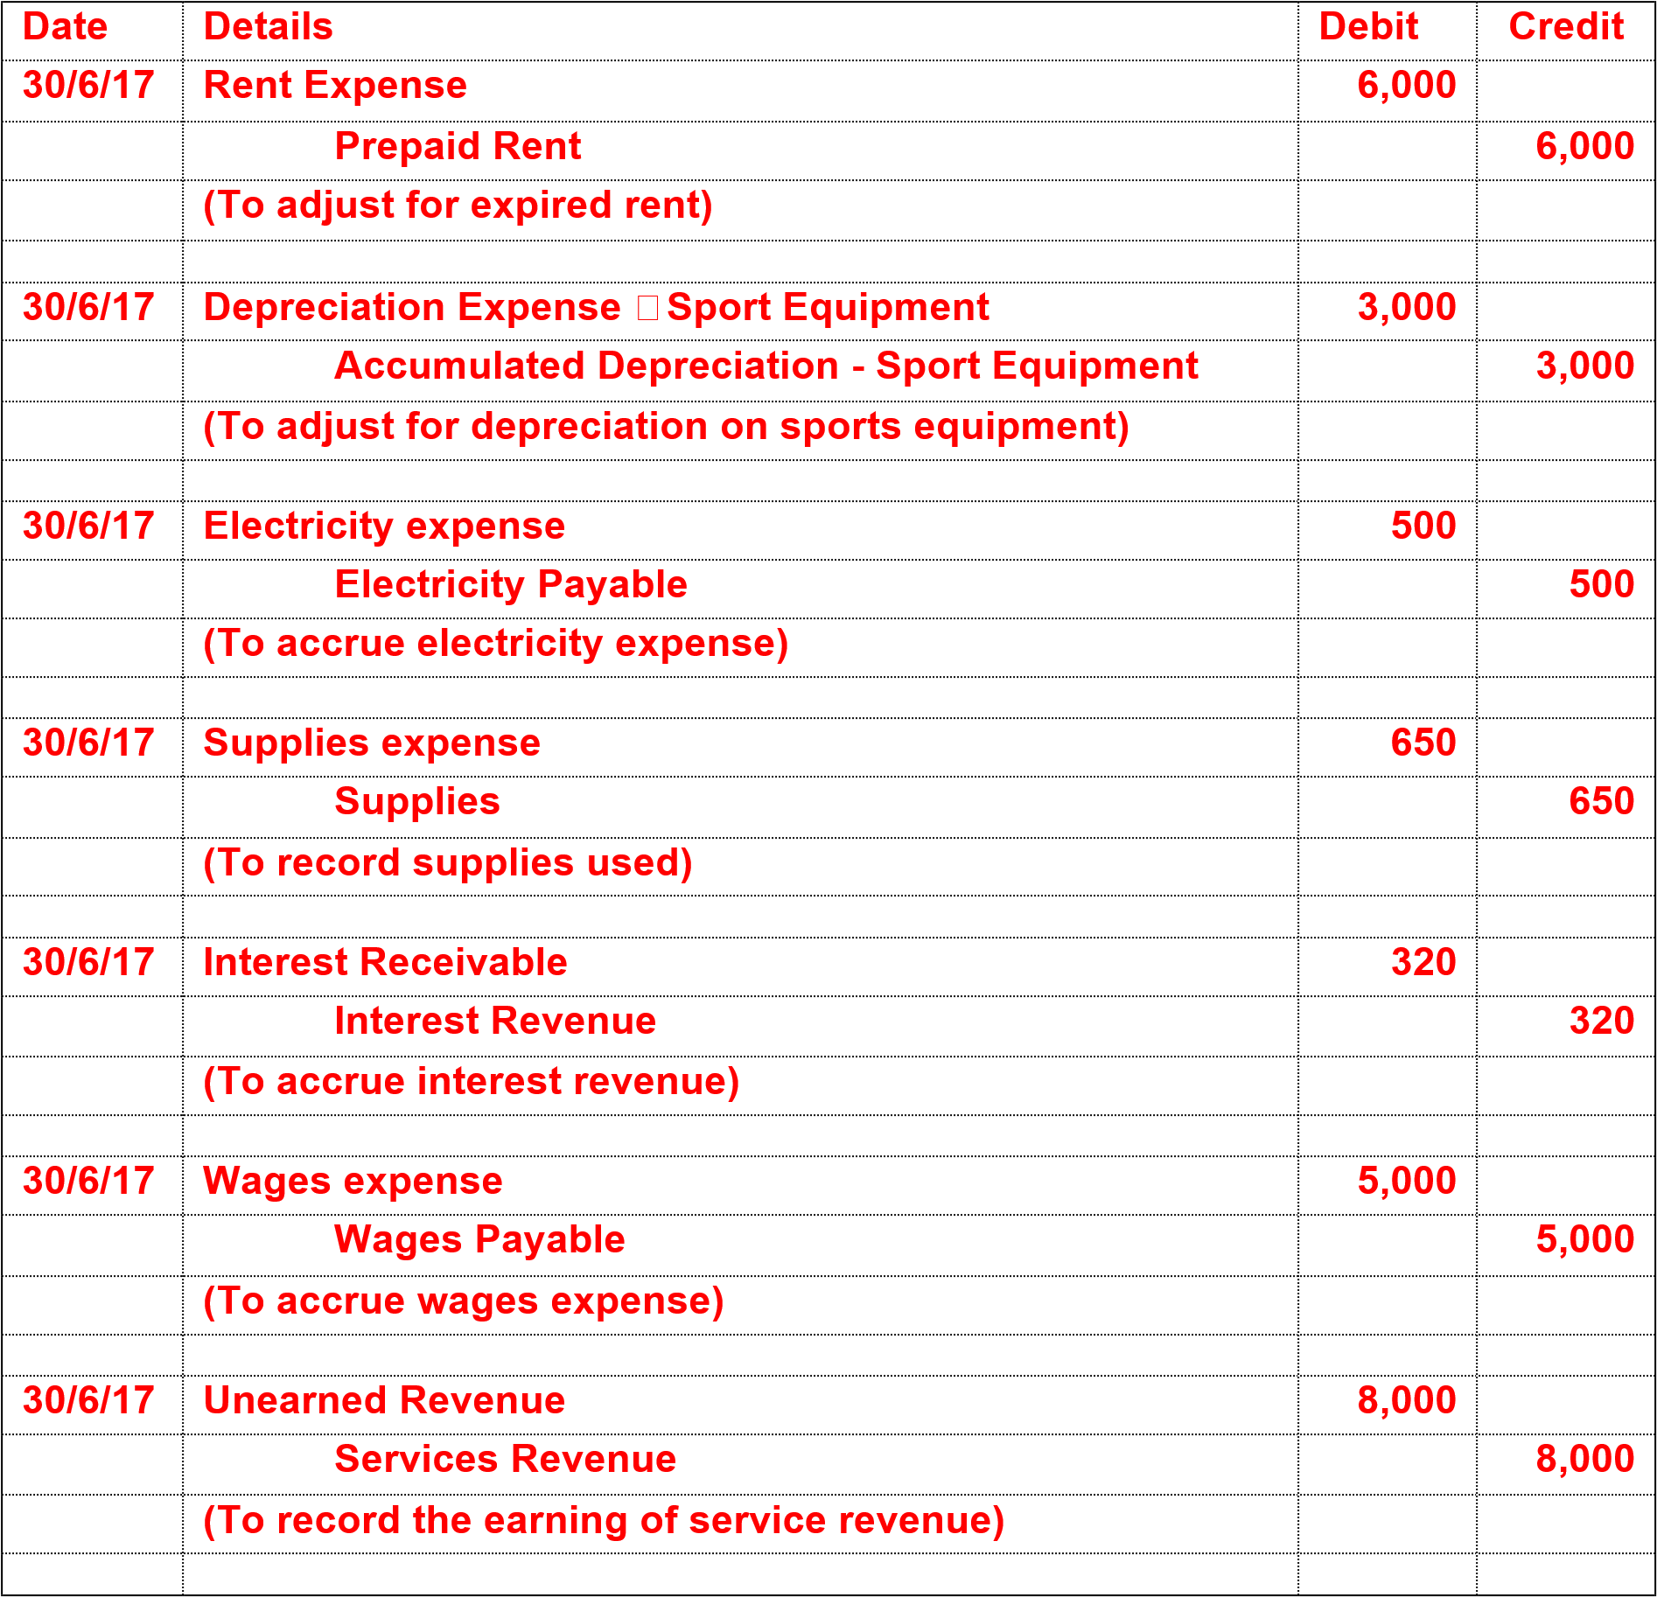

**3** The manager of Marks Lamps uses the FIFO method of determining the cost of stock. The following information relates to the purchase and sale of desk lamp model S45, during May 2010. On May 1, there were 10 lamps in stock at a cost of $14 each.

|  |  |  |  |  |  |
| --- | --- | --- | --- | --- | --- |
| **PURCHASES** | | | **SALES** | | |
| May | 2 | 50 lamps @ $14 each | May | 3 | 40 lamps @ $28 each |
|  | 4 | 40 lamps @ $15 each |  | 5 | 15 lamps @ $28 each |
|  | 9 | 50 lamps @ $15 each |  | 12 | 30 lamps @ $30 each |
|  | 24 | 50 lamps @ $16 each |  | 19 | 50 lamps @ $30 each |
|  |  |  |  | 27 | 20 lamps @ $30 each |
|  |  |  |  | 29 | 20 lamps @ $32 each |
| At the end of May, as determined by a physical stocktake, there were 25 lamps in stock | | | | | |

Complete the stock card below. Adjust the stock cards for any stock losses or stock gains revealed by the stocktake.

**SOLUTION**

|  |  |  |  |  |  |  |  |  |  |  |
| --- | --- | --- | --- | --- | --- | --- | --- | --- | --- | --- |
| **Stock Card for Lamps FIFO** | | | | | | | | | | |
| **MAY** | **TRANSACTION** | **IN** | | | **OUT** | | | **BALANCE** | | |
|  |  | qty | cost | value | qty | cost | value | qty | cost | value |
| 1 | Balance |  |  |  |  |  |  | 10 | 14 | 140 |
| 2 | Purch | 50 | 14 | 700 |  |  |  | 60 | 14 | 840 |
| 3 | Sale |  |  |  | 40 | 28 | 1120 | 20 | 14 | 280 |
| 4 | Purch | 40 | 15 | 600 |  |  |  | 20  40 | 14  15 | 280  600 |
| 5 | Sale |  |  |  | 15 | 28 | 420 | 20-15=5  40 | 14  15 | 70  600 |
| 9 | Purch | 50 | 15 | 750 |  |  |  | 5  40+50=90 | 14  15 | 70  1350 |
| 12 | Sale |  |  |  | 30 | 30 | 900 | 5-5=0  90-25=65 | 15 | 975 |
| 19 | Sale |  |  |  | 50 | 30 | 1500 | 65-50=15 | 15 | 225 |
| 24 | Purch | 50 | 16 | 800 |  |  |  | 15  50 | 15  16 | 225  800 |
| 27 | Sale |  |  |  | 20 | 30 | 600 | 15-15=0  50-5=45 | 16 | 720 |
| 29 | Sale |  |  |  | 20 | 32 | 640 | 45-20=25 | 16 | 400 |
| 31 | BALANCE |  |  |  |  |  |  | 25 |  | 400 |
| 31 | STOCK LOSS |  |  |  | none |  |  |  |  |  |

**Part C - Extended Answer - 2Questions – 10 marks each – total 2 marks**

The following is a list of items for the period ending and as at 30 June, 2015

for Kailee’s Plumbing Services (a Sole Proprietorship):

|  |  |  |
| --- | --- | --- |
| **ITEM** | **AMOUNT$** | **CATEGORY** |
| Capital - Kailee | 12,000 |  |
| Cash at bank | 11,850 |  |
| Prepaid Rent for July and August | 1,200 |  |
| Motor Vehicle | 18,000 |  |
| Loan | 30,000 |  |
| Accounts Payable | 5,750 |  |
| Drawings - Kailee | 1,150 |  |
| Electricity paid | 500 |  |
| Telephone paid | 650 |  |
| Sales/Fees | 14,150 |  |
| Materials on hand | 7,200 |  |
| Accounts Receivable | 10,000 |  |
| Interest paid | 3,000 |  |
| Wages expense | 5,200 |  |
| Stationery on hand | 550 |  |
| Accrued wages | 1,200 |  |
| Computer | 3,200 |  |
| Rent paid | 600 |  |

**Required:**

1. Prepare an **Income Statement** for the period ending 30 June, 2015.
2. Prepare a **Balance Sheet** as at 30 June, 2015.

**Income Statement**

**For period ended for the month ended 30 June, 2015**

|  |  |  |
| --- | --- | --- |
|  | **$** | **$** |
| Revenue |  |  |
|  |  |  |
|  |  |  |
| Less Expenses |  |  |
|  |  |  |
|  |  |  |
|  |  |  |
|  |  |  |
|  |  |  |
| **Net Profit/Loss** |  |  |

**Balance Sheet - For month ended 30 June, 2015**

|  |  |  |  |
| --- | --- | --- | --- |
| **Assets** | **$** | **Liabilities** | **$** |
|  |  |  |  |
|  |  |  |  |
|  |  |  |  |
|  |  |  |  |
|  |  | *Total Liabilities* |  |
|  |  |  |  |
|  |  | **Owners’ Equity** |  |
|  |  | Capital |  |
|  |  | **Add** Net Profit |  |
|  |  |  |  |
|  |  | **Less** Drawings |  |
|  |  |  |  |
|  |  | *Total Owners’ Equity* |  |
|  |  |  |  |
| **TOTAL ASSETS** |  | **TOTAL EQUITIES** |  |

**SOLUTION.**

# Income Statement

**For period ended for the month ended 30 June, 2015**

|  |  |  |
| --- | --- | --- |
|  | **$** | **$** |
| **Revenue** |  |  |
| Sales |  | **14,150** |
|  |  |  |
| **Less Expenses** |  |  |
| Electricity | 500 |  |
| Telephone | 650 |  |
| Interest | 3,000 |  |
| Wages | 5,200 |  |
| Rent | 600 | **9,950** |
| **NET PROFIT** |  | **$4,200** |

# Balance Sheet For month ended 30 June, 2015

|  |  |  |  |
| --- | --- | --- | --- |
| **Assets** | **$** | **Liabilities** | **$** |
| Cash at Bank | 11,850 | Accrued Wages | 1,200 |
| Prepaid Rent | 1,200 | Accounts Payable | 5,750 |
| Materials on hand | 7,200 | Loan | 30,000 |
| Stationery on hand | 550 |  |  |
| Accounts Receivable | 10,000 | *Total Liabilities* | **36,950** |
| Computer | 3,200 |  |  |
| Motor Vehicle | 18,000 | **Owners’ Equity** |  |
|  |  | Capital | 12,000 |
|  |  | **Add Net Profit** | 4,200 |
|  |  |  | 16,200 |
|  |  | **Less** Drawings | (1,150) |
|  |  | *Total Owners’ Equity* | **15,050** |
|  |  |  |  |
| **TOTAL ASSETS** | **$52,000** | **TOTAL EQUITIES** | **$52,000** |

## REVISION Income Statement and Balance Sheet



**COMBINED BALANCE SHEET AND INCOME STATEMENT – SOLUTION**





